Imagine you are wearing a pair of Max’s Magnificent Glasses. Draw and write... what can you see and do when you are wearing ‘magical’ glasses?

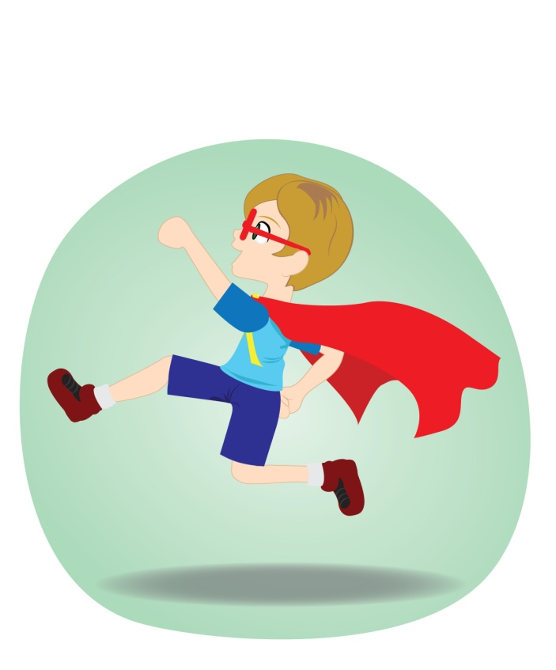

Spiders 8 Media copyright 2016
Word Find - Find words from Max’s Magnificent Glasses that are hidden in the box below.
m |  | a | m | n | i | b | u | s | h | c | l | s
l |  | l | e | w | k | n | i | f | s | s | i | m
n |  | a | f | h | o | t | n | k | w | s | o | a
l |  | c | r | o | f | l | e | c | s | g | n | x
k |  | i | n | d | e | r | g | a | r | t | e | n
j |  | g | p | u | z | z | l | e | d | i | a | j
e |  | a | s | g | d | g | u | j | i | r | x | k
p |  | m | a | g | n | i | f | i | c | e | n | t
u | n |  | d | w | e | l | b | v | z | t | s | p
magnificent amnibus magical max
glasses miss finkwell kindergarten puzzle
Can you find any other words? ________________________

- What does Max imagine he is having for dinner?

- What does Max imagine he is climbing?

- The other children in Max’s class are wearing different coloured glasses. What colour glasses would you choose and why?

- What do you think Max did the next day when he was wearing his ‘magical’ glasses?

Spiders 8 Media copyright 2016

